cloudli connect app | installation GUIDE |
DESKTOP APPLICATION

Table of Contents
PRE-REQUISITE 2
Download Cloudli Desktop App 2
Credential 2
ACCOUNT SET UP 3

PRE-REQUISITE

Download Cloudli Desktop App

To download Cloudli Connect desktop app,
- In your internet browser, enter
  - WINDOWS : https://apps.cloudli.com/connect/cloudliconnectinstall.exe
  - MAC : https://apps.cloudli.com/connect/cloudliconnectinstall.pkg
- At the bottom left of your screen, the Cloudli Connect installer will automatically start downloading.
- Complete the installation process.
- After the successful installation, launch the application.

Credential
In order to use the app, you will need your Cloudli Connect Portal username and password. If you do not already have an End User Portal login and/or password, click here.

ACCOUNT SET UP
To set up the account, follow the steps outlined below
- Once the application is installed, launch the application. This will direct you to the login screen.

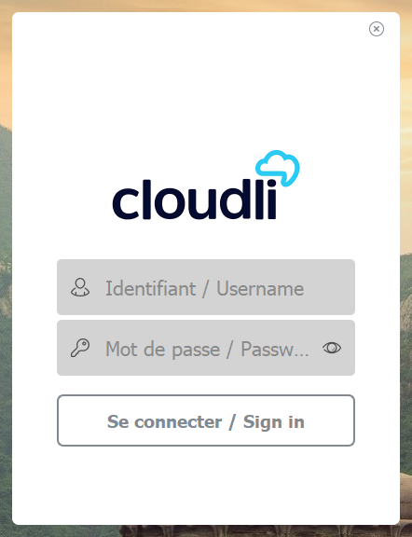
- Enter the same username and password that you use to access the Cloudli Connect Portal.
- Click Sign In. You will be navigated to the application; you are all set!
