Cloudli connect app | INSTALLATION GUIDE |
ANDROID DEVICES

Table of Contents
PRE-REQUISITE 2
Download apps to your Android device 2
Credential 2
ACCOUNT SET UP 3
CONFIGURATIONS 4
Set Permission 4
Microphone Permission 4
Phone Permission 5
Contact Permission 5
Ignore Battery Permission 6
Fullscreen incoming calls 7

PRE-REQUISITE

Download apps to your Android device

To install Cloudli Connect mobile app,
- Open the play store on the target Android device and download the Cloudli Connect mobile app.
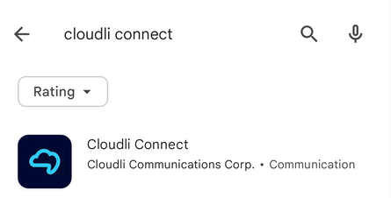
- Once it’s downloaded, install the mobile app.

- After the successful installation, launch the application.

Credential
In order to use the app, you will need your Cloudli Connect Portal username and password. If you do not already have an End User Portal login and/or password, click here.

ACCOUNT SET UP
To set up the account, follow the steps outlined below
- Once the application is installed, launch the application. This will direct you to the login screen.

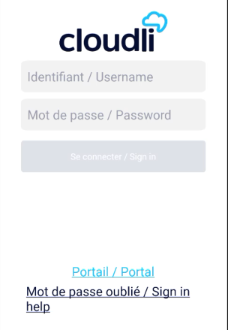

- Enter the same username and password that you use to access the Cloudli Connect Portal.
- Click Sign in.

CONFIGURATIONS

Set Permission

To use the Cloudli Connect mobile app, you need to grant access and allow the following permission.

Microphone Permission
In the Microphone permission settings,
- Click Next. A new pop-up will appear.
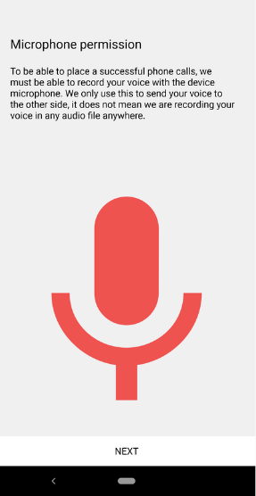

- Click while using the app on the popup.
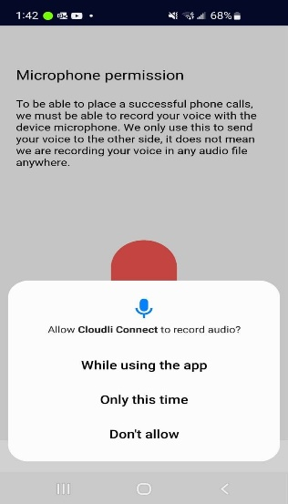
.

Phone Permission
In the Phone permission settings,

- Click Next. A new pop-up will appear.
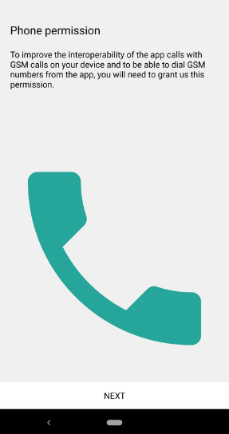

- Click Allow on the popup.
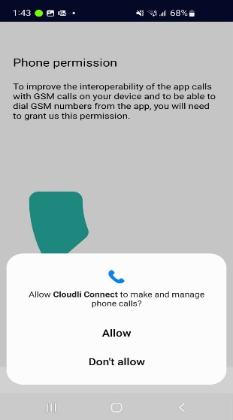

Contact Permission
In the Contact permission settings,
- Click Next. A new pop-up will appear.
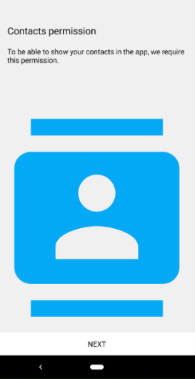

- Click DON’T ALLOW if you wish to keep your personal and business contacts separate. Otherwise, click Allow on the popup.

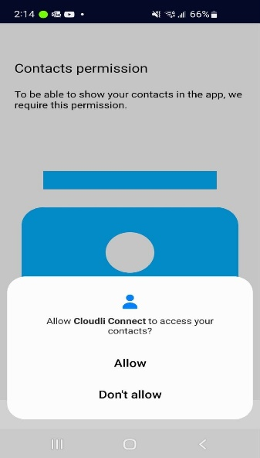

Ignore Battery Permission
In the ignore Battery Optimization settings,

- Click Next. A new pop-up will appear.
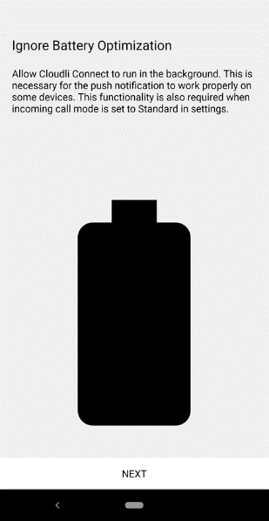

- Click Allow on the popup.
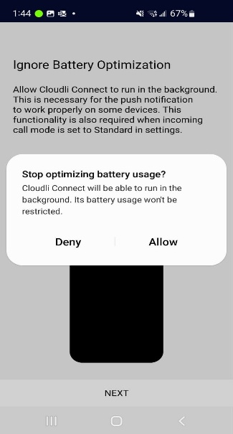

Fullscreen incoming calls
In the Fullscreen incoming calls settings,

- Click Next. A new pop-up will appear.
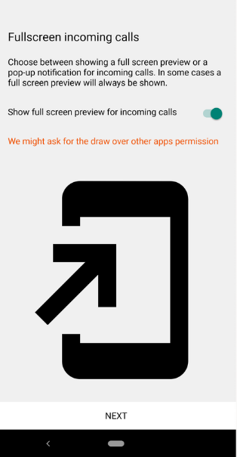

- Click SETTINGS. A new pop-up Display over other apps appear with list of all the application.
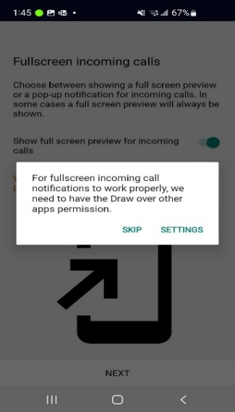

- Look for Cloudli Connect in the list.
- Click the Cloudli Connect. A new pop-up will appear.
- Click Allow display over other apps to enable it.

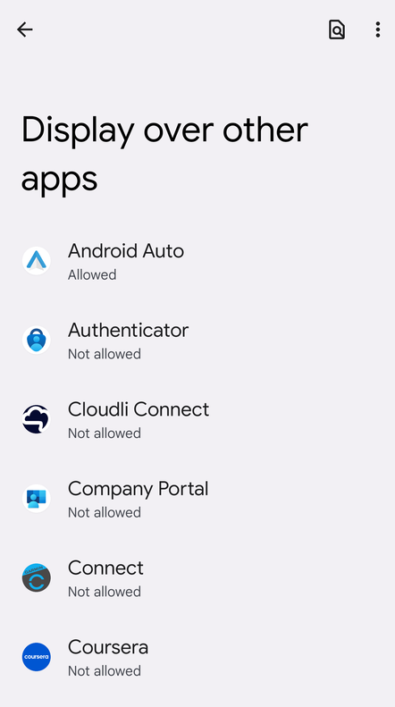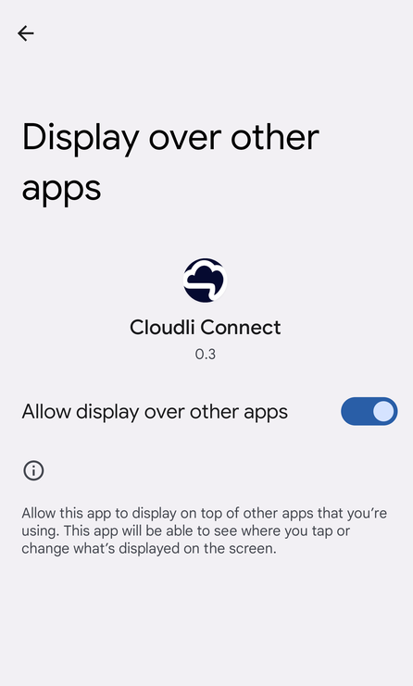

- You will be navigated to the application; you are all set!

