CLOUDLI CONNECT APP | USER GUIDE |
IPHONE DEVICES

Table of Contents
PRE-REQUISITE 2
Download apps to your iPhone device 2
Credential 2
ACCOUNT SET UP 3
CONFIGURATIONS 4
Set Permission 4
MAIN TABS 6
Quick Dial 7
Call History 8
Keypad 9
Messages 9
Contacts 10
Call manager 11
Settings 11
Account Setup 12
Preference 12

PRE-REQUISITE

Download apps to your iPhone device
To install Cloudli Connect mobile app,
- Open the App Store on the target iPhone device and download the Cloudli Connect mobile app.
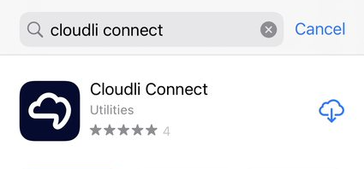
- Once it’s downloaded, install the mobile app.
- After the successful installation, launch the application.

Credential
In order to use the app, you will need your Cloudli Connect Portal username and password. If you do not already have an End User Portal login and/or password, Click here.

ACCOUNT SET UP
To set up the account, follow the steps outlined below
- Once the application is installed, launch the application. This will direct you to the login screen.
- Enter the same username and password that you use to access the Cloudli Connect Portal.
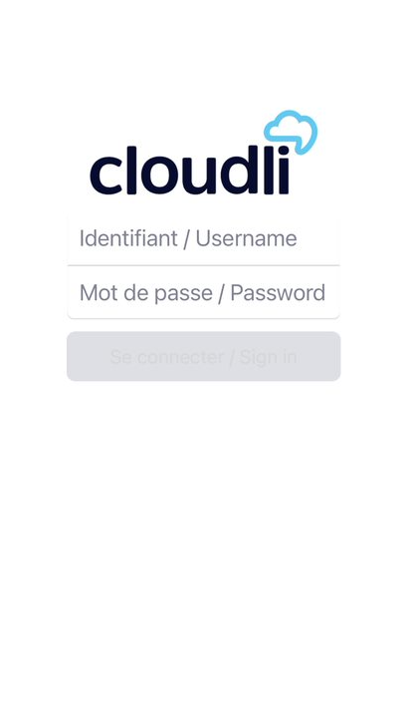
- Click Sign in.

CONFIGURATIONS

Set Permission

To use the Cloudli Connect mobile app, you need to grant access and allow the following permission.

- In the send notification, click Allow.
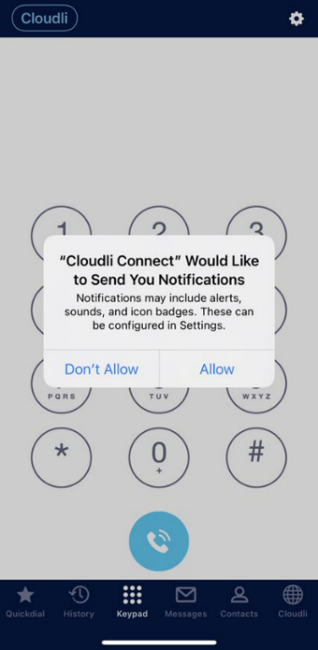

- In the Access Contacts, click DON’T ALLOW if you wish to keep your personal and business contacts separate. Otherwise, click OK on the popup.
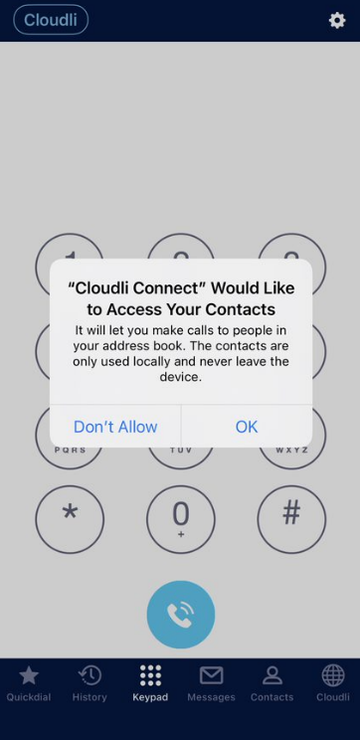
3. You will be navigated to the application; you are all set!
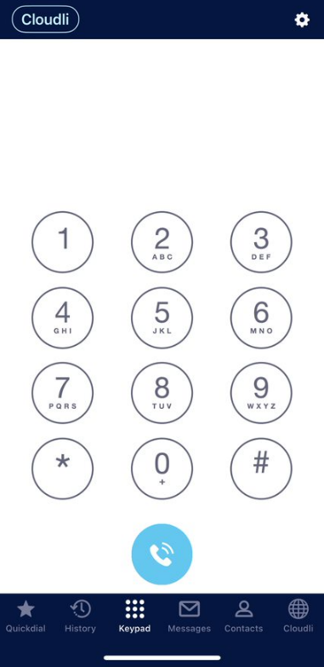

.

MAIN TABS

All of the primary tabs are situated along the bottom of the app. There are several tabs in the main display that provide details on the contacts and available communication methods.

- Quick Dial
- History
- Keypad
- Messages
- Contact List
- Call manager

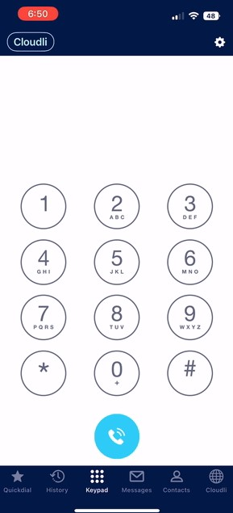
Quick Dial
Quick dial is located on bottom Menu all the way to the left. The quick dial allows a user to dial a specific number with a single button press.

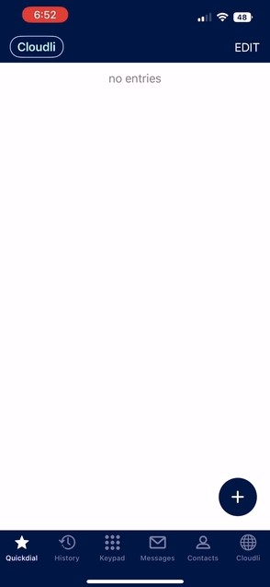
To add a new contact to the quick dial,
- Tap the “+” icon in the lower right corner or MODIFY at the top right corner. A new screen will appear.
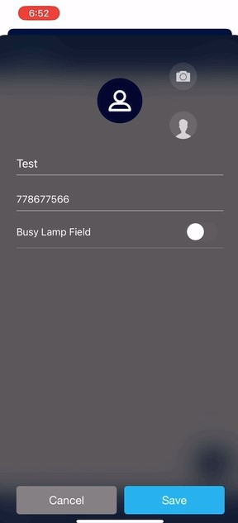
- Enter the Title and Phone Number.
- If the user is a member of your organization, enable the Busy Lamp Field to indicate whether the user is currently on or off the phone.(Coming soon!)
- Tap Save.

Call History
Call History is Located on the bottom Menu next to the left of the Keypad icon. The Cloudli Connect mobile app stores its own call logs independently of the logs kept by the user.

To edit your call history, go to the top right corner and tap the EDIT button.

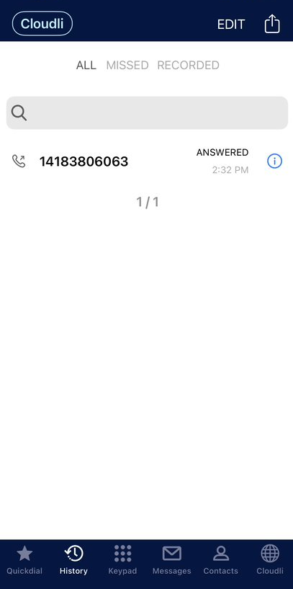

Keypad
The keypad functions similarly to a regular phone's, allowing you to place calls to certain numbers.
The keypad interface is the starting point for exploring the various features and customization options available in the Cloudli Connect mobile app. Click on the gear button to access the Settings.

Messages
Text message tab located on the far right of the bottom Menu allows you to send, receive, and manage text messages.
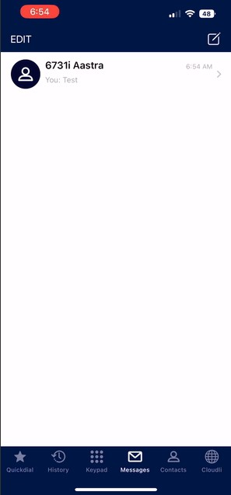

Contacts

On the bottom Menu, select the icon to the right of the keypad icon to access contacts.

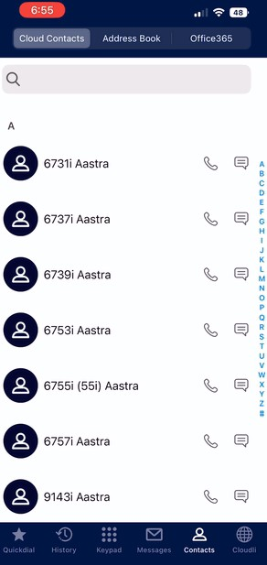
Call Manager

The Cloudli icon allow you to access directly to your call manager on the Cloudli Connect portal.

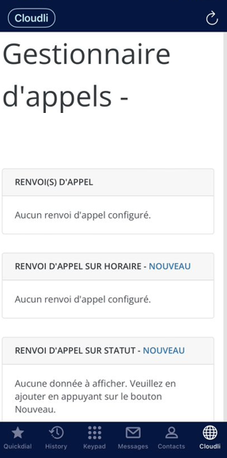

Settings
Settings allows you to personalize your Apps, phone number, ring tone, and gain access to privacy policies, terms of service, and other features.

To access settings,

- Click the setting icon () in the upper right corner of the Keypad tab. A new screen will appear with a list of all the features.
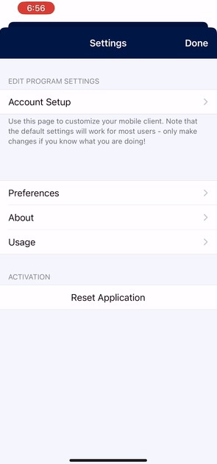

Account Setup
Account setup allows you to configure your existing cloudli account.
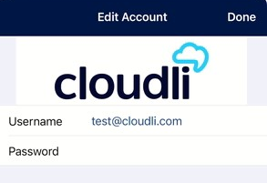

Preference
The PREFERENCES feature enables you to "customize" your Cloudli Connect mobile application to your desire. It contains standard options such as ringtones and complex features like as mobile and personal phone interaction. It also controls the display language of the mobile app, which supports 29 different languages.

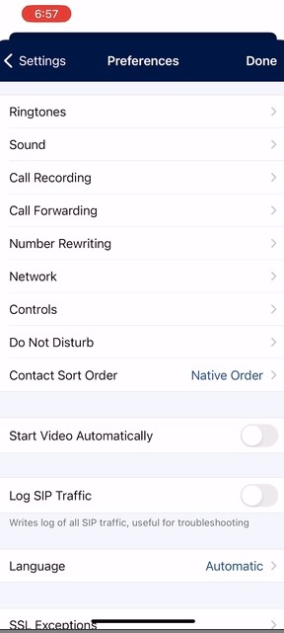

Ringtone

Ringtone allows you to customize your own ringtones and text tones. They are setup by default to have a different ringtone for VoIP Cloudli calls than what is preset for personal calls.
To customize your ringtone, navigate to Settings > Preference > Ringtone.
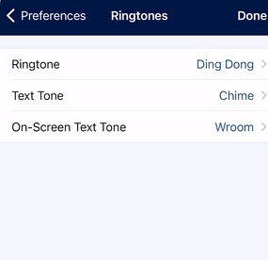

Sound

The optimal sound settings are activated by default. It is NOT advised that you modify these parameters. To customize your ringtone, navigate to Settings > Preference > Sound.
Bluetooth must be enabled in order for Bluetooth headsets and Bluetooth car integration to function. The Cloudli Connect mobile app must be paired exactly like any other Bluetooth device. Compose the two volume amplification settings for the microphone and keypad via the sound section.
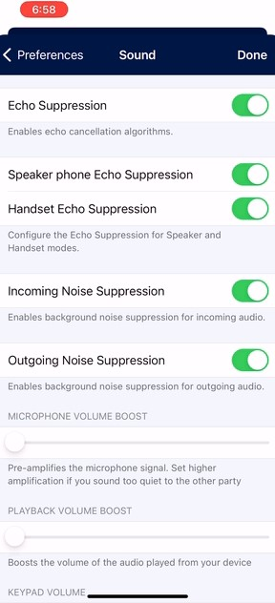

Call Forwarding
Call forwarding allows you to redirect a call to a different number. To enable this feature, navigate to Settings > Preference > Call Forwarding.

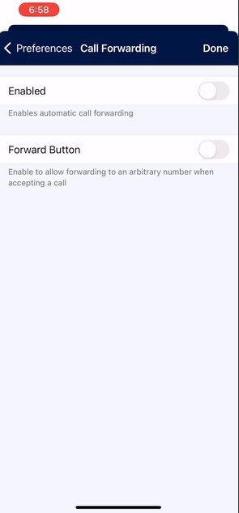
WARNING! Changing these settings might impact the Cloudli Connect call control settings for routing, ring groups, and call centers. If these settings are altered and help is required to fix them, there will be a $250 service fee per incident.

Number Rewriting

Number rewriting is a feature of Softphone that enables you to manipulate the dialed numbers. To enable this feature, navigate to Settings > Preference > Number Rewriting.
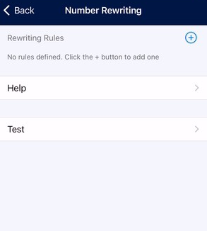
To add a new writing rule,
- Tap on the “+” icon in the upper right corner. A new screen will appear.
- Tap on the “+” icons to add Conditions and Actions. A new screen will appear with list of conditions and actions.
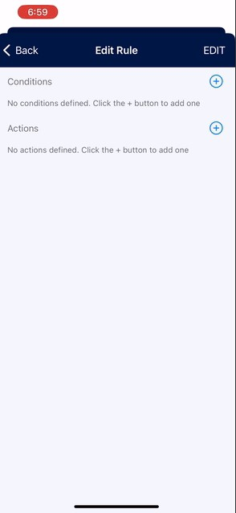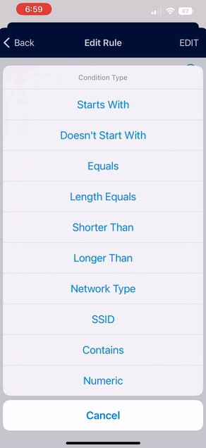

Network
Network enables you to configure the network preference to either Prefer WiFi or Prefer Mobile Data based on your workplace.

Network setting SHOULD NOT BE CHANGED as this will result in issues when switching from Wi-Fi to Mobile Data networks.

NOTE: Please be aware that using mobile data will consume data from your mobile carrier's plan.

To configure network feature, navigate to Settings > Preference > Network.

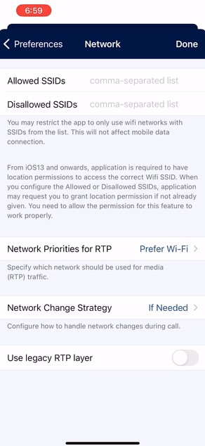

Controls
The Controls section enables more specific controls for managing the application. GSM call settings controls the phone's behavior when you are on a VCC app call and another call comes in on your personal cellular number.
It can be set up in the following ways-
- DO NOTHING,
- PUT ON HOLD, or
- PLAY MUSIC.

To configure control, navigate to Settings > Preference > Control.
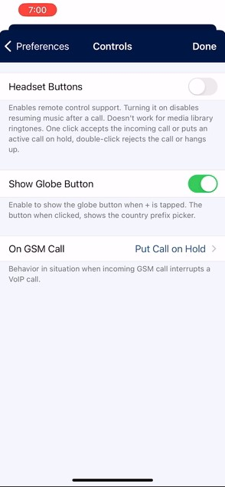

DND (DO NOT DISTURB)

DND enables you to opt out of call notification within the VCC app once you have logged in. DO NOT DISTURB mode can be activated at any time. The DND mode will only apply to the VCC app and not affect any other devices registered to your extension.
To configure DND, please follow the instructions outlined below.
- Navigate to Settings > Preference > Do not disturb.
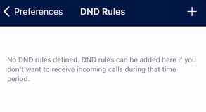

- Tap on the Add (+) button. A new window will appear.
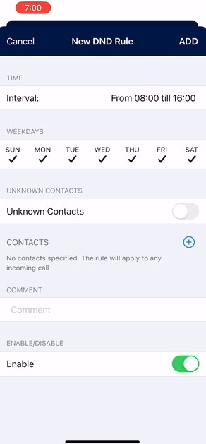
- Select the required fields, then tap the ADD button.
NOTE: The DND mode will only apply to the Cloudli Connect app and not affect any other devices registered to your extension.

- To activate the DND option, on the main screen, click on your company name in the blue circle at the top left of the application, you will be able to activate the DND function.
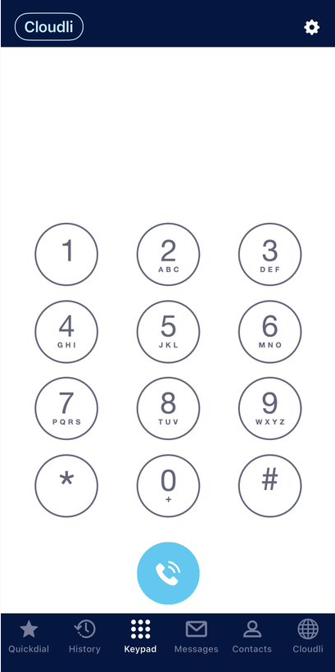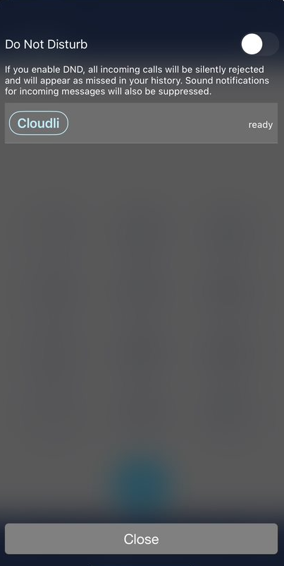

Contact Sort Order

This feature enables you to controls whether contacts are listed by their Native, First, or Last Name. To configure Contact Sort Order, navigate to Settings > Preference > Contact Sort Order.
