CLOUDLI CONNECT APP | USER GUIDE |
ANDROID DEVICES
Table of Contents
PRE-REQUISITE 2
Download apps to your Android device 2
Credential 2
ACCOUNT SET UP 3
CONFIGURATIONS 4
Set Permission 4
Microphone Permission 4
Phone Permission 5
Contact Permission 5
Ignore Battery Permission 6
Fullscreen incoming calls 7
MAIN TABS 10
Quick dial 11
Recent 12
Keypad 12
Messages 13
Contacts 13
Call Manager 14
Settings 14
Account Setup 15
Preference 15

PRE-REQUISITE

Download apps to your Android device

To install Cloudli Connect mobile app,
- Open the play store on the target Android device and download the Cloudli Connect mobile app.
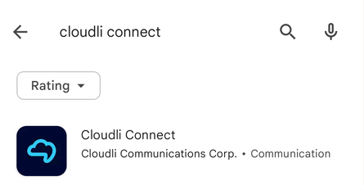
- Once it’s downloaded, install the mobile app.

- After the successful installation, launch the application.

Credential
In order to use the app, you will need your Cloudli Connect Portal username and password. If you do not already have an End User Portal login and/or password, click here.

ACCOUNT SET UP
To set up the account, follow the steps outlined below
- Once the application is installed, launch the application. This will direct you to the login screen.

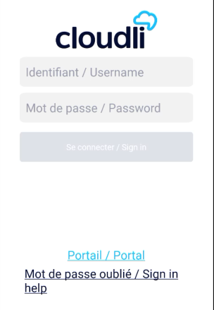

- Enter the same username and password that you use to access the Cloudli Connect Portal.
- Click Sign In.

CONFIGURATIONS

Set Permission

To use the Cloudli Connect mobile app, you need to grant access and allow the following permission.

Microphone Permission
In the Microphone permission settings,
- Click Next. A new pop-up will appear.
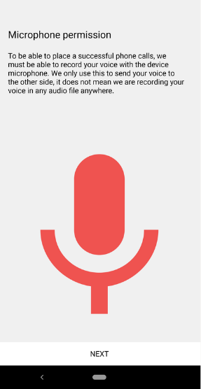
- Click while using the app on the popup.
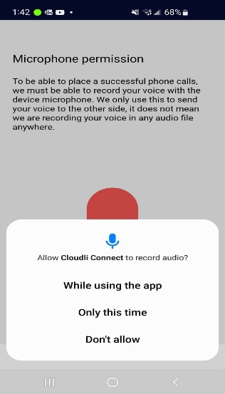

Phone Permission
In the Phone permission settings,

- Click Next. A new pop-up will appear.
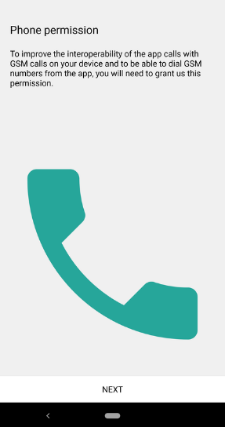

- Click Allow on the popup.
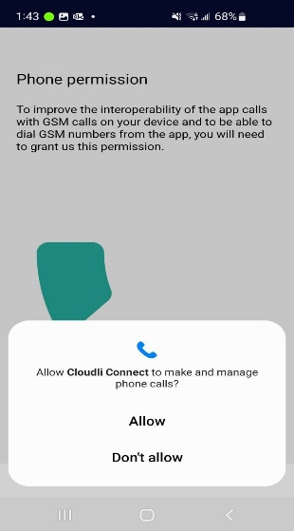

Contact Permission
In the Contact permission settings,
- Click Next. A new pop-up will appear.
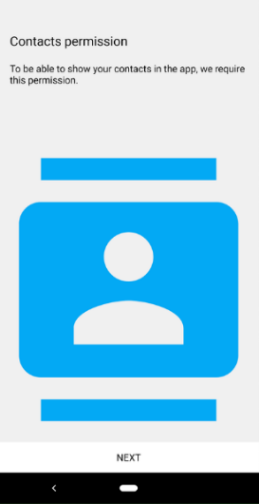

- Click Allow on the popup.
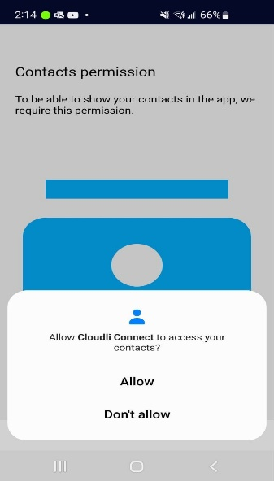
NOTE: The Cloudli Connect app will import your EXISTING PERSONAL CONTACTS if you give it permission to access contacts on your phone. Click "Don't Allow" if you wish to keep your personal and business contacts separate.

Ignore Battery Permission
In the ignore Battery Optimization settings,

- Click Next. A new pop-up will appear.
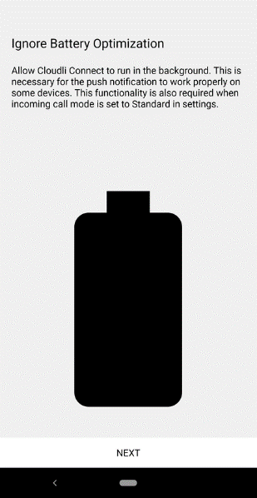

- Click Allow on the popup.
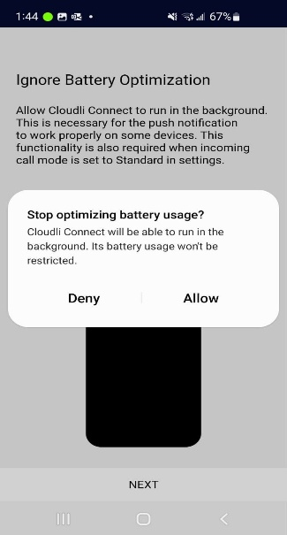

Fullscreen incoming calls
In the Fullscreen incoming calls settings,

- Click Next. A new pop-up will appear.
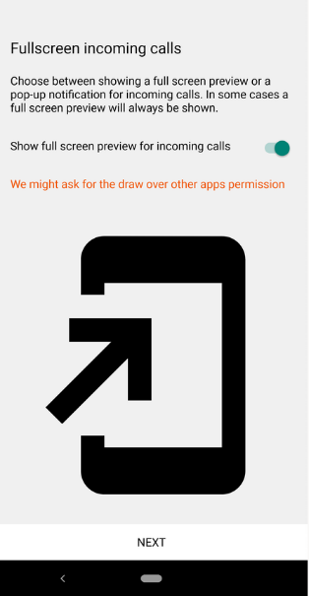
- Click SETTINGS. A new pop-up Display over other apps appear with list of all the application.
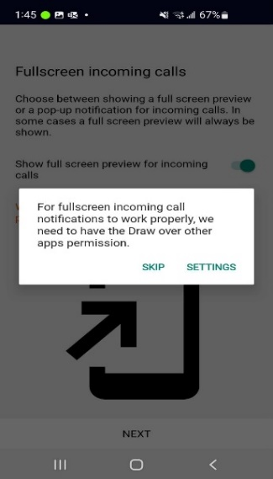
- Look for Cloudli Connect in the list.
- Click the Cloudli Connect. A new pop-up will appear.
- Click Allow display over other apps to enable it.
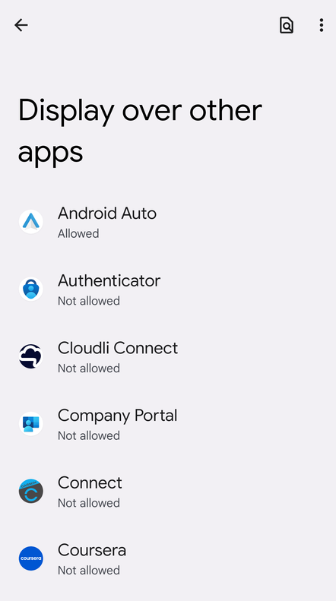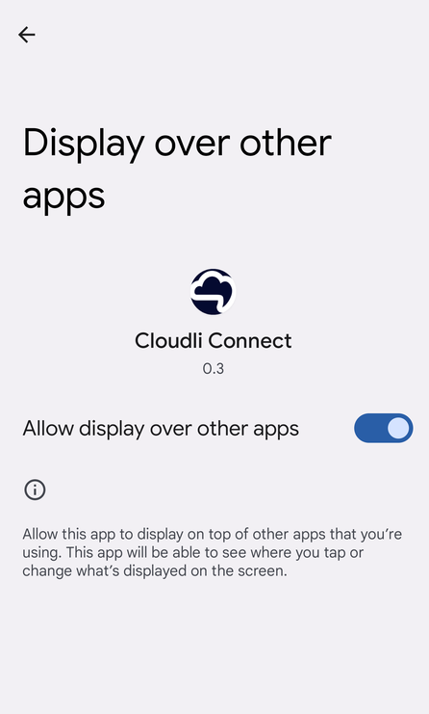

- You will be navigated to the application; you are all set!

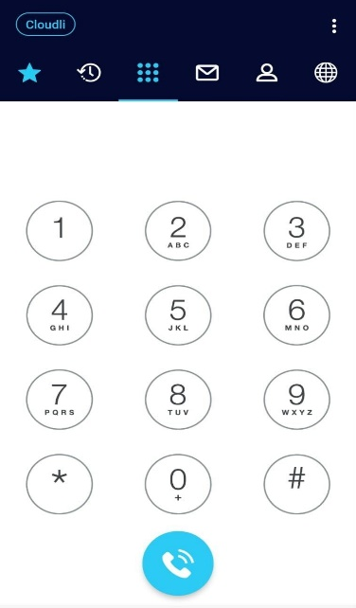

MAIN TABS

All of the primary tabs are situated along the top of the app. There are several tabs in the main display that provide details on the contacts and available communication methods.

- Quick Dial
- Call History
- Key Pad
- Messages
- Contact List
- Call manager
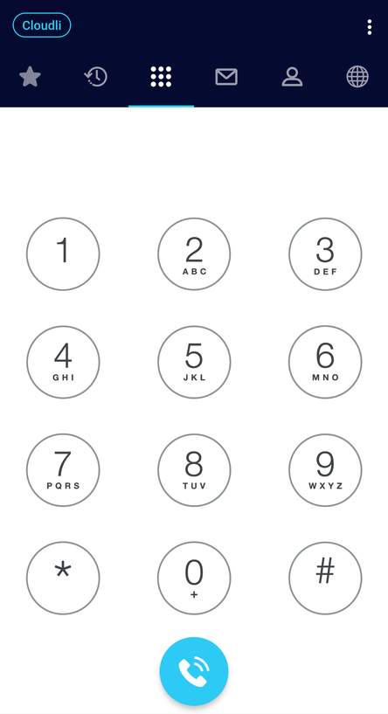

Quick dial
Quick dial is located on top Menu all the way to the left. The quick dial allows a user to dial a specific number with a single button press.

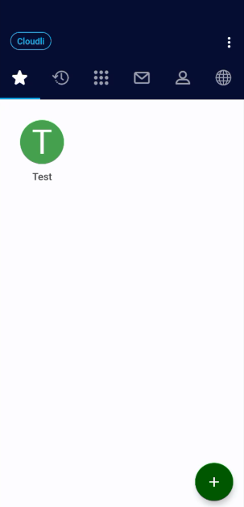
If the user is a member of your organization, enable the Busy Lamp Field to indicate whether the user is currently on or off the phone.

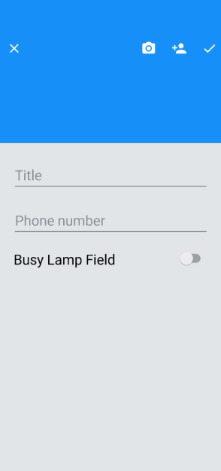
Call History
Call History is Located on the top Menu next to the left of the Keypad icon. The cloudli mobile app stores its own call logs independently of the logs kept by the user.

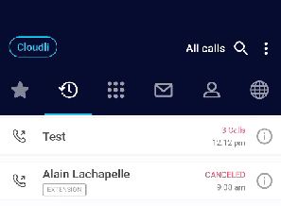
Keypad
The keypad functions similarly to a regular phone's, allowing you to place calls to certain numbers.
The keypad interface is the starting point for exploring the various features and customization options available in the Cloudli Connect mobile app. Click on the three-dots button to access the Settings.

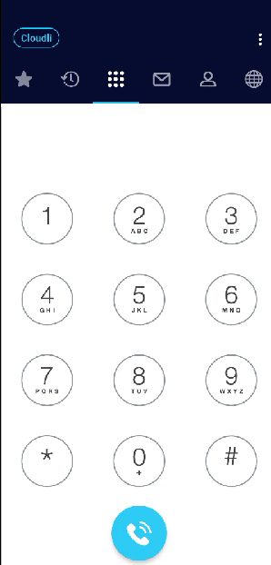
Messages
Text message tab located on the far right of the top Menu allows you to send, receive, and manage text messages.
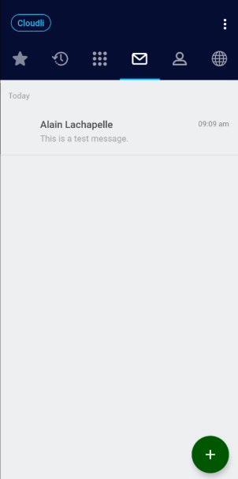
Contacts

On the top Menu, select the icon to the right of the keypad icon to access contacts.
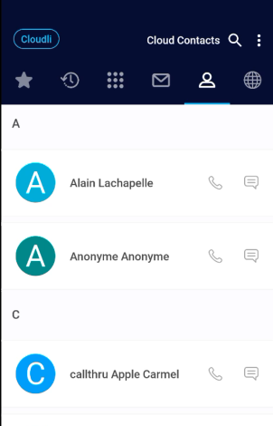
Call Manager

The Cloudli icon allow you to access directly to your call manager on the Cloudli Connect portal.

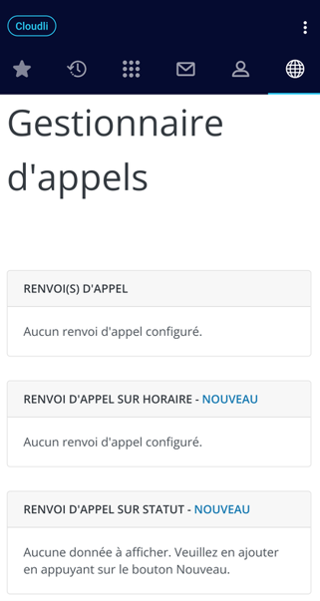

Settings
Settings allows you to personalize your apps, phone number, ring tone, and gain access to privacy policies, terms of service, and other features.

To access settings,

- Click the three-dot button in the upper right corner of the Keypad tab. A new screen will appear with a list of all the features.
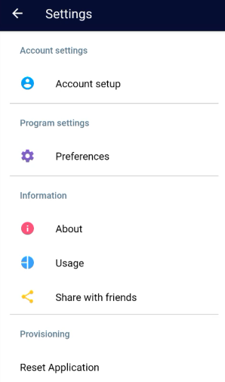

Account Setup
Account setup allows you to configure your existing Cloudli Connect account.
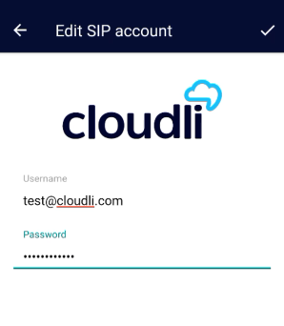

Preferences
The PREFERENCES feature enables you to "customize" your Cloudli Connect mobile application to your desire. It contains standard options such as ringtones and complex features like as mobile and personal phone interaction. It also controls the display language of the mobile app, which supports 29 different languages.

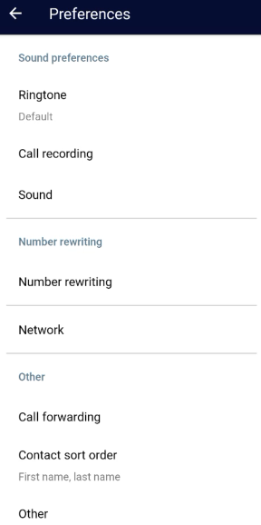

Ringtone

Ringtone allows you to customize your own ringtones and text tones. They are setup by default to have a different ringtone for VoIP Cloudli calls than what is preset for personal calls.
To customize your ringtone, navigate to Settings > Preference > Ringtone.
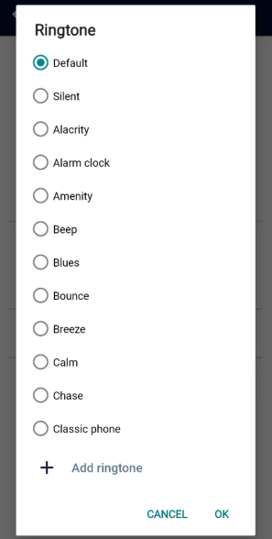

Sound

The optimal sound settings are activated by default. It is NOT advised that you modify these parameters. To customize your ringtone, navigate to Settings > Preference > Sound.
Bluetooth must be enabled in order for Bluetooth headsets and Bluetooth car integration to function. The Cloudli Connect mobile app must be paired exactly like any other Bluetooth device. Compose the two volume amplification settings for the microphone and keypad via the sound section.
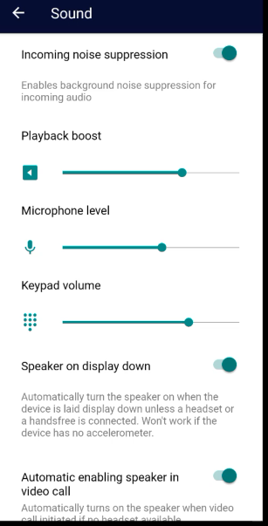
Call Forwarding
Call forwarding allows you to redirect a call to a different number. To enable this feature, navigate to Settings > Preference > Call Forwarding.

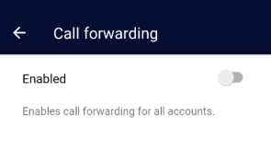
WARNING! Changing these settings might impact the Cloudli Connect call control settings for routing, ring groups, and call centers. If these settings are altered and help is required to fix them, there will be a $250 service fee per incident.

Number Rewriting

Number rewriting is a feature of Softphone that enables you to manipulate the dialed numbers. To enable this feature, navigate to Settings > Preference > Number Rewriting.
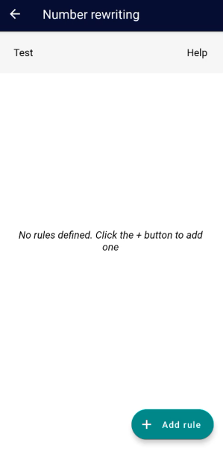

Network
Network enables you to configure the network preference to either Prefer WiFi or Prefer Mobile Data based on your workplace.

Network setting SHOULD NOT BE CHANGED as this will result in issues when switching from Wi-Fi to Mobile Data networks.
NOTE: Please be aware that using mobile data will consume data from your mobile carrier's plan.

To configure network feature, navigate to Settings > Preference > Network.
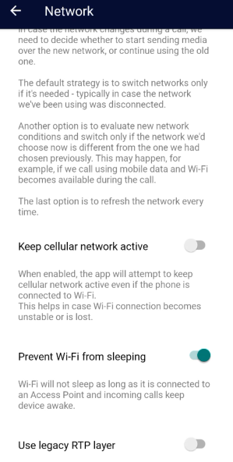
Controls
The Controls section enables more specific controls for managing the application. GSM call settings controls the phone's behavior when you are on a Cloudli Connect app call and another call comes in on your personal cellular number.

It can be set up in the following ways-
- DO NOTHING,
- PUT ON HOLD, or
- PLAY MUSIC.
To configure control, navigate to Settings > Preference > Control.
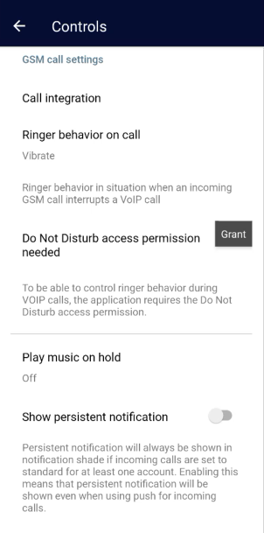

DND (DO NOT DISTURB)

DND enables you to opt out of call notification within the Cloudli Connect app once you have logged in. DO NOT DISTURB mode can be activated at any time. The DND mode will only apply to the Cloudli Connect app and not affect any other devices registered to your extension.
To configure DND, please follow the instructions outlined below.
- Navigate to Settings > Preference > Do not disturb.
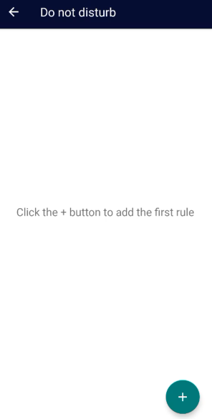
- Select the Add (+) button. A new window will appear.
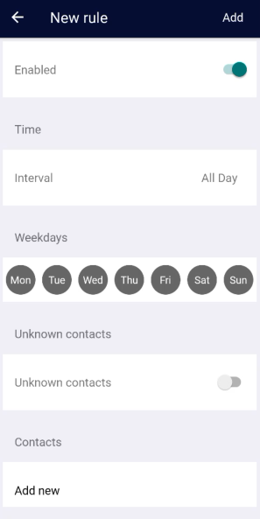
- Select the necessary fields, then select Add.

NOTE: The DND mode will only apply to the Cloudli Connect app and not affect any other devices registered to your extension.

- To activate the DND option, on the main screen, click on your company name in the blue circle at the top left of the application, you will be able to activate the DND function.

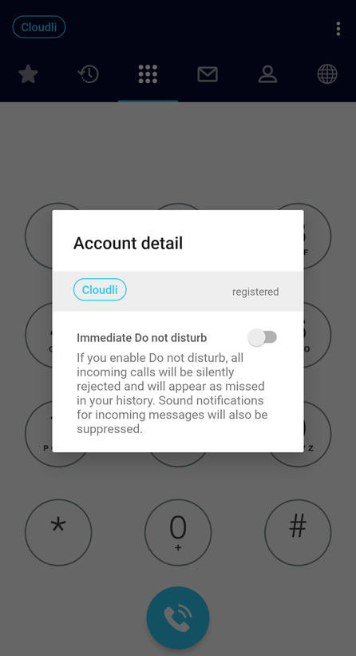

Contact Sort Order

This feature enables you to controls whether contacts are listed by their Native, First, or Last Name. To configure Contact Sort Order, navigate to Settings > Preference > Contact Sort Order.
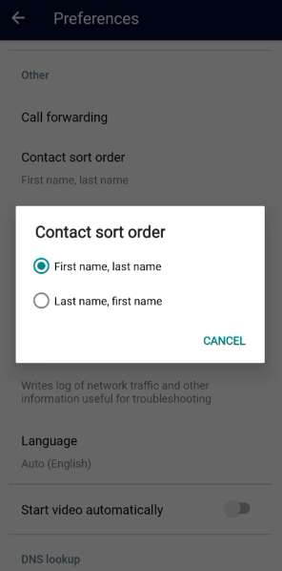

Troubleshooting log

A troubleshooting log is a record of every error that happens while the program is running. To configure troubleshooting log, navigate to Settings > Preference > Troubleshooting log.
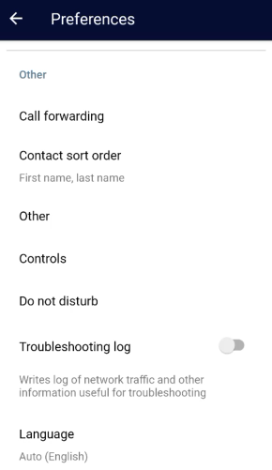
Note: During troubleshooting, Cloudli may urge you to enable this to aid in problem resolution. Otherwise, please leave this setting unchecked because it will eat storage space on your mobile phone.

