CLOUDLI CONNECT APP | INSTALLATION GUIDE |
IPHONE DEVICES

Table of Contents
PRE-REQUISITE 2
Download apps to your iPhone device 2
Credential 2
ACCOUNT SET UP 3
CONFIGURATIONS 4
Set Permission 4

PRE-REQUISITE

Download apps to your iPhone device
To install Cloudli Connect mobile app,
- Open the App Store on the target iPhone device and download the Cloudli Connect mobile app.
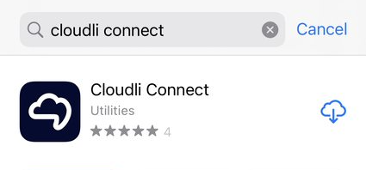

- Once it’s downloaded, install the mobile app.

- After the successful installation, launch the application.

Credential
In order to use the app, you will need your Cloudli Connect Portal username and password.
If you do not already have an End User Portal login and/or password, Click here.

ACCOUNT SET UP
To set up the account, follow the steps outlined below
- Once the application is installed, launch the application. This will direct you to the login screen.

- Enter the same username and password used to access the Cloudli Connect Portal.

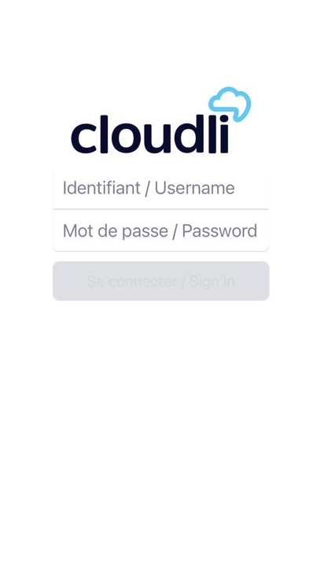

- Click Sign in.

CONFIGURATIONS

Set Permission

To use the Cloudli Connect mobile app, you need to grant access and allow the following permission.

- In the send notification, click Allow.
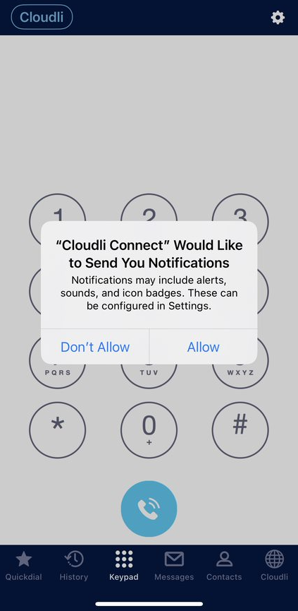
- In the Access Contacts, click DON’T ALLOW if you wish to keep your personal and business contacts separate. Otherwise, click OK on the popup.
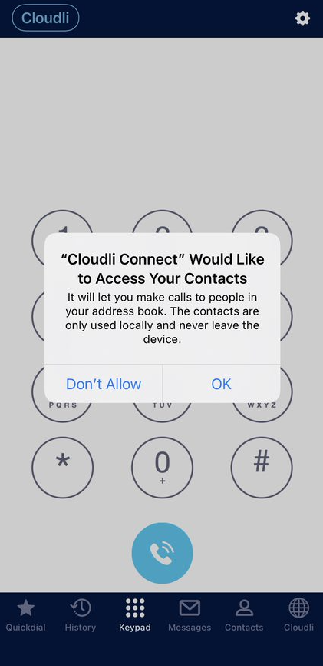
- You will be navigated to the application; you are all set!




