CLOUDLI CONNECT APP | USER GUIDE | DESKTOP APPLICATION

Table of Contents
PRE-REQUISITE 2
Download Cloudli Desktop App 2
Credential 2
ACCOUNT SET UP 3
MAIN TABS 4
Dialpad 5
Contact 5
Messages 6
Recent 7
Cloudli (Call manager) 8
Settings 8
About 9
Accounts 10
Notification 10
Sound 11
Recording 12
Control 12
Logs 13
Reset 14

PRE-REQUISITE

Download Cloudli Desktop App

To download Cloudli Connect desktop app,
- In your internet browser, enter
  - WINDOWS : https://apps.cloudli.com/connect/cloudliconnectinstall.exe
  - MAC : https://apps.cloudli.com/connect/cloudliconnectinstall.pkg
- At the bottom left of your screen, the Cloudli Connect installer will automatically start downloading.
- Complete the installation process.
- After the successful installation, launch the application.

Credential
In order to use the app, you will need your Cloudli Connect Portal username and password. If you do not already have an End User Portal login and/or password, click here.

ACCOUNT SET UP
To set up the account, follow the steps outlined below
- Once the application is installed, launch the application. This will direct you to the login screen.

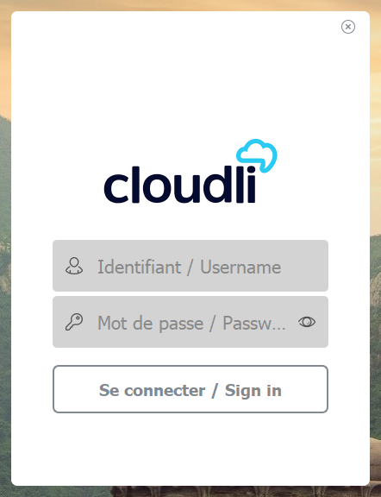
- Enter the same username and password that you use to access the Cloudli Connect Portal.
- Click Sign In. You will be navigated to the application; you are all set!
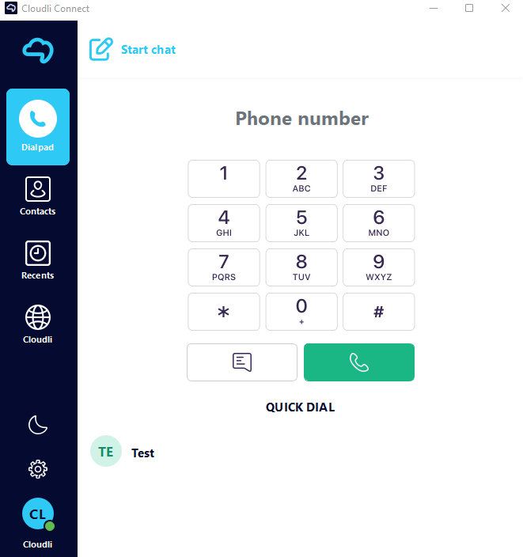

MAIN TABS

All of the primary tabs are grouped on the left side of the screen. There are several tabs in the main display that provide details on the contacts and available communication methods.

- Dialpad
- Contact
- Recent
- Cloudli Connect (Call manager)
- Do not disturb
- Settings
Dialpad
The Dialpad functions similarly to a regular phone's, allowing you to place calls to certain numbers. The keypad interface is the starting point for exploring the various features and customization options available in the VCC browser app.

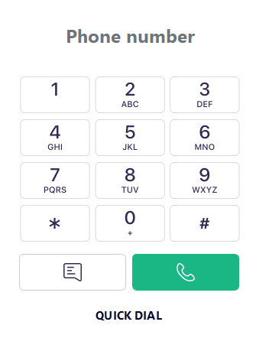

Contact

Contact has a list of all your contacts from A to Z and a search bar that you can use to find someone in particular.
You can also access your Quick Dial, Cloud Contact and any call groups you have created—all from the drop-down menu at the top.
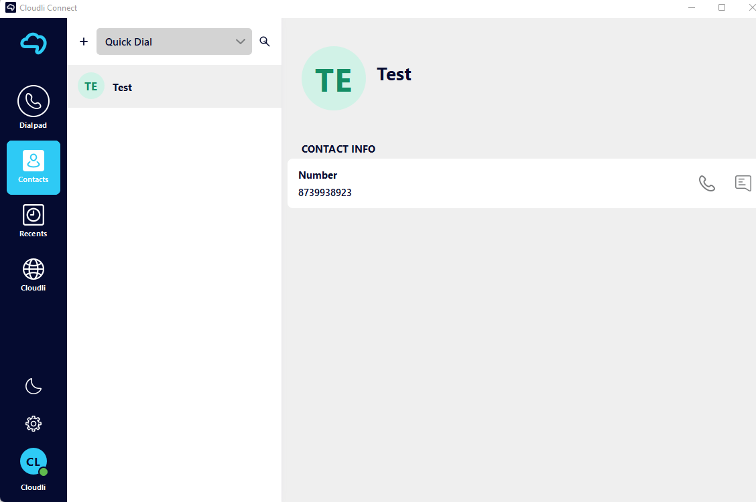

You can also access your Quick Dial, Cloud Contact and any call groups you have created—all from the drop-down menu at the top.
If you want to add a new contact to your list,
- Click Add (+) at the top of your list. A new window will appear.
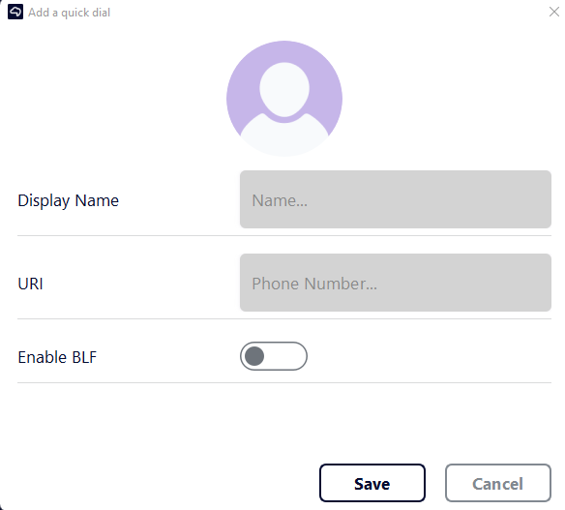
- Enter the Name and Phone Number.
- Select the Enable BLF (Busy Lamp Field) if required. If the user is a member of your organization, enable the BLF to indicate whether the user is currently on or off the phone.
- Click Save.

Messages

Message icon is located on the far right of the contact allows you to send, receive, and manage text messages.

To send a message,
- Click on the message icon. A new window will appear.
- Type the required message and hit enter.

Recent

Recent stores all the recent call log for your device.

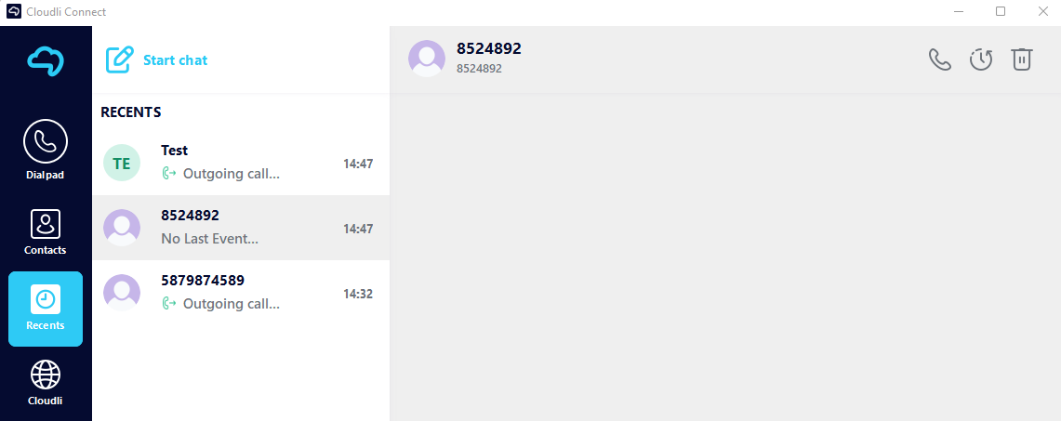

Cloudli (Call Manager)

The Cloudli icon allow you to access directly to your call manager on the Cloudli Connect portal.

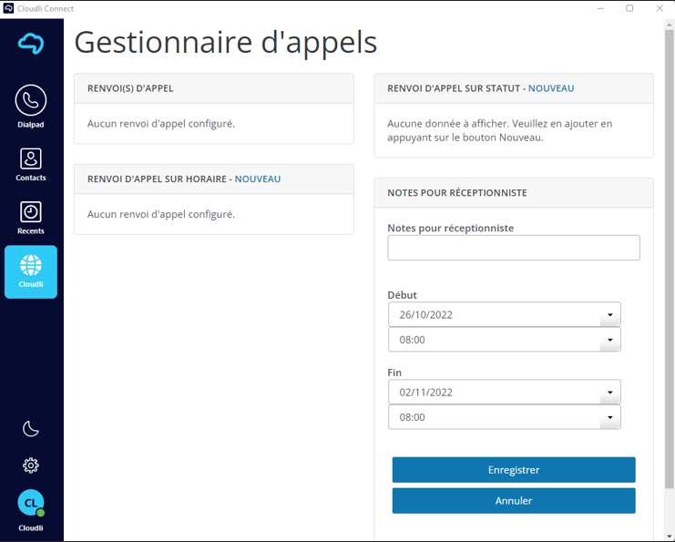

Settings

Settings allows you to personalize your Apps, phone number, ring tone, and gain access to privacy policies, terms of service, and other features.

To access settings,

Click the Setting icon (gear icon) in the bottom left corner. A new screen will appear with a list of all the features.
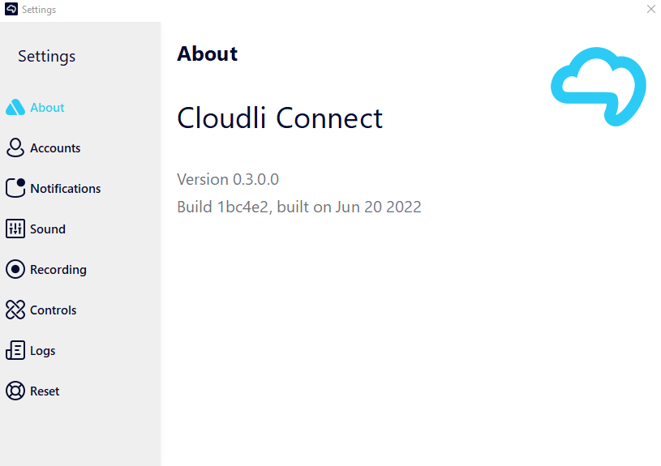

About

In the About section, you can view what version of the application you're using. To view the about section, navigate to Settings > About.

Accounts

Account setup allows you to configure your existing cloudli account. To configure account, navigate to Settings > Accounts.

This is also where you can authorize access to your Office 365 contacts.

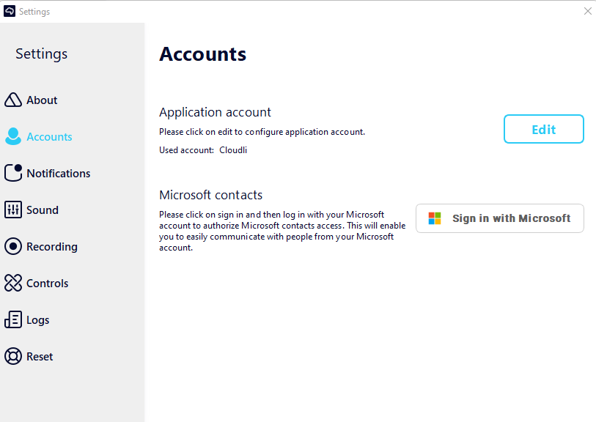

To edit the existing Cloudli Connect account,
- Click the Edit button. A new window will appear.
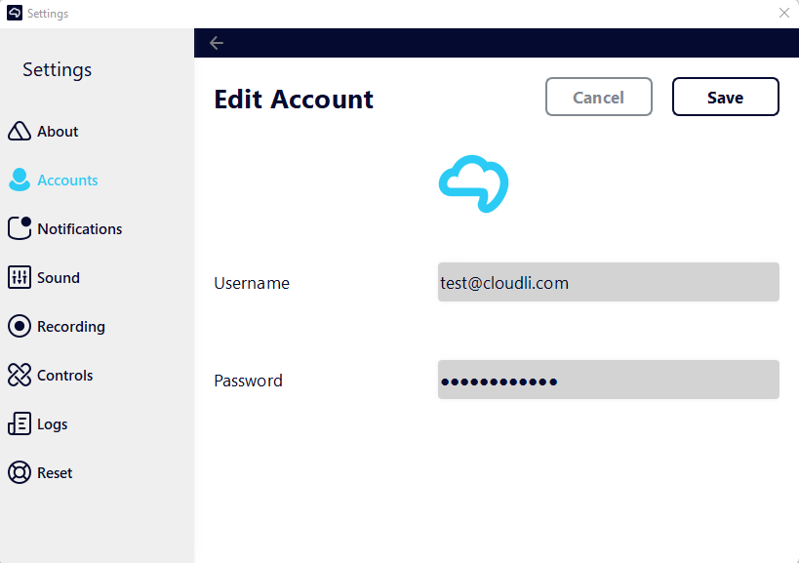
- Enter the Username and Password.
- Click Save.

Notifications

A notification is a message, sound, or sign on your phone or computer that tells you that someone has given you a message or that something new has been added for you to look at.

To configure account, navigate to Settings > Notifications.

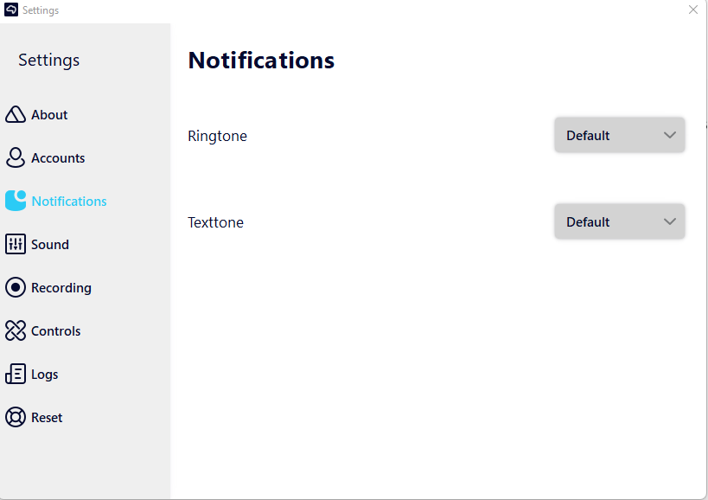

The drop-down box allows you to choose the preferred Ringtone and Texttone.

Sound

Sounds Settings allows you to customize numerous sound settings, such as loudness and eco-cancellation. It also permits the selection of output speaker, microphone, Ringtone audio output etc. To configure sound, navigate to Settings > Sound.
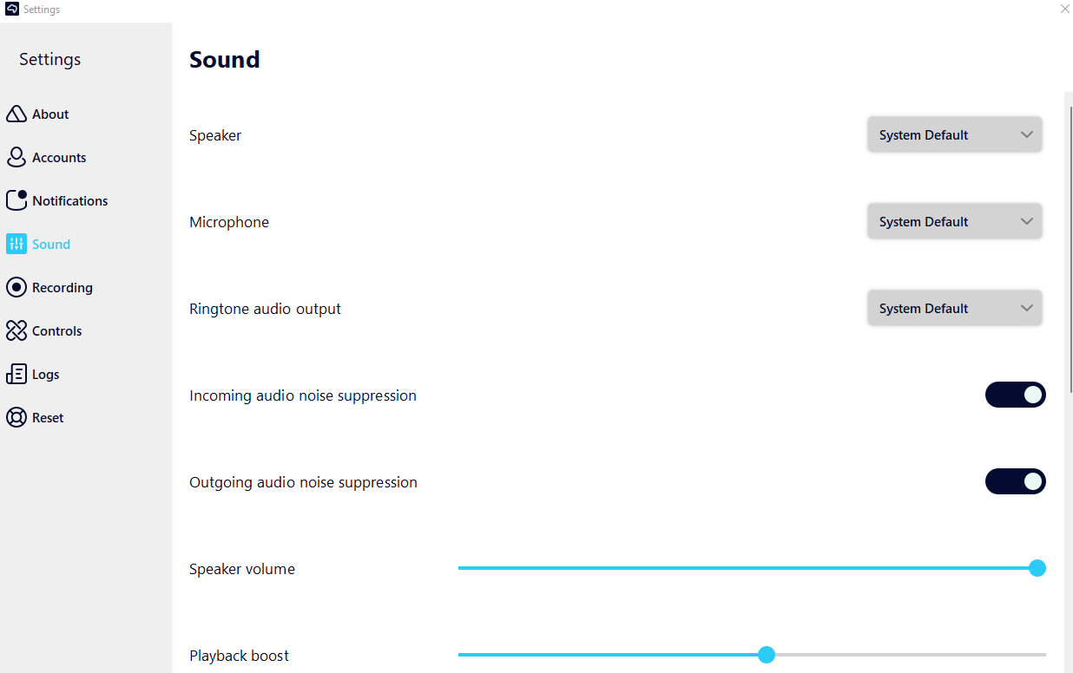
The optimal sound settings are activated by default. It is NOT advised that you modify these parameters. Bluetooth must be enabled in order for Bluetooth headsets and Bluetooth car integration to function

Recording

Calls can be recorded and played back at a later time. In addition to capturing audio, the recording also allows for its secure distribution within the organization.

To configure the recording, navigate Settings > Recording.

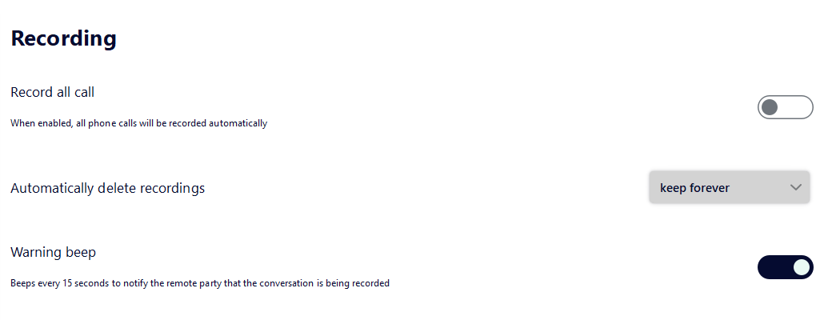

The drop-down box allows you to specify the time after which recorded files will be automatically erased.

Controls

The control allows you to control how the application behaves and other aspects of its functionality.

To configure application behavior, navigate Settings > Control.

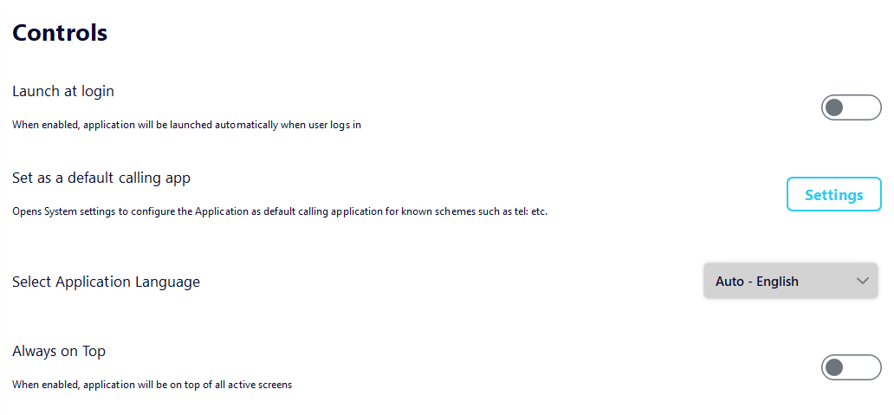

Logs

A log is a record of every error that happens while the program is running. To configure log, navigate to Settings > Troubleshooting log.
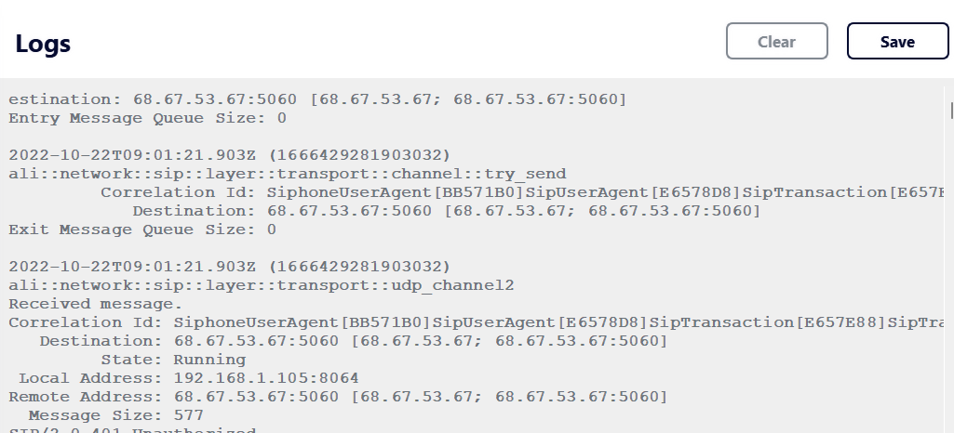

To save system logs, click the Save button in the top right corner.

Reset

Resetting your app will return it to the same state it was in the first time you turned it on. This action will wipe all your settings and history.

To reset your application,

- Navigate to Settings > Reset.
- A conformation window will appear.
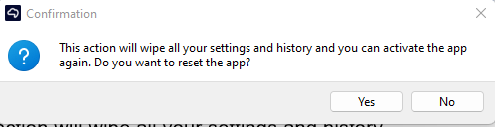
- Click Yes.

